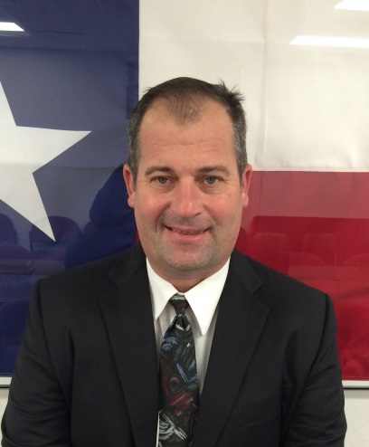

**800 North Vineyard**

|  |
| --- |
|  |

|  |
| --- |
| **Jason R. Woods, Director**  **36th, 156th & 343rd Judicial District Community Supervision and Corrections Department**  **VISION STATEMENT**  Establish public protection, through implementation and utilization of a graduated continuum of correctional sanctions and services to eliminate criminal behavior.  **MISSION STATEMENT** |

Provide for victim restitution, community service restitution, reform, reintegration, treatment and appropriate restraint for those persons charged with or convicted of criminal offenses.

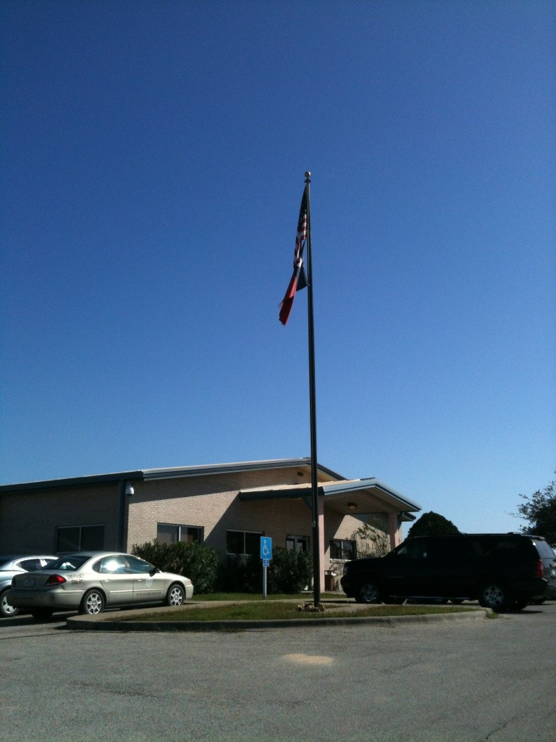

IT STAFFING SOLUTIONS

Pala, metuo obruo opes ratis commoveo at.

Blandit haero melior quibu, saepius ne hendrerit iustum validus

nulla indoles gemino pneum. Lorem ipsum dolor ergo mita vita sanctum espa molor deai.

simplifying **IT**

consulting

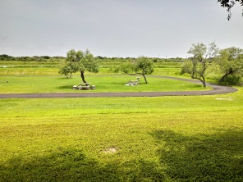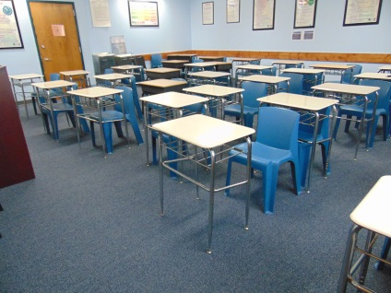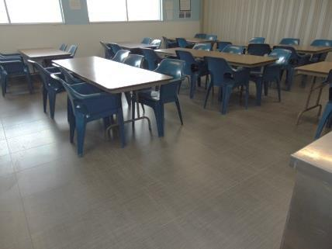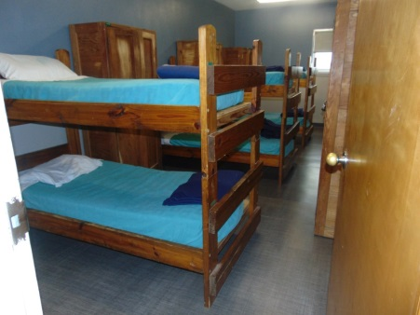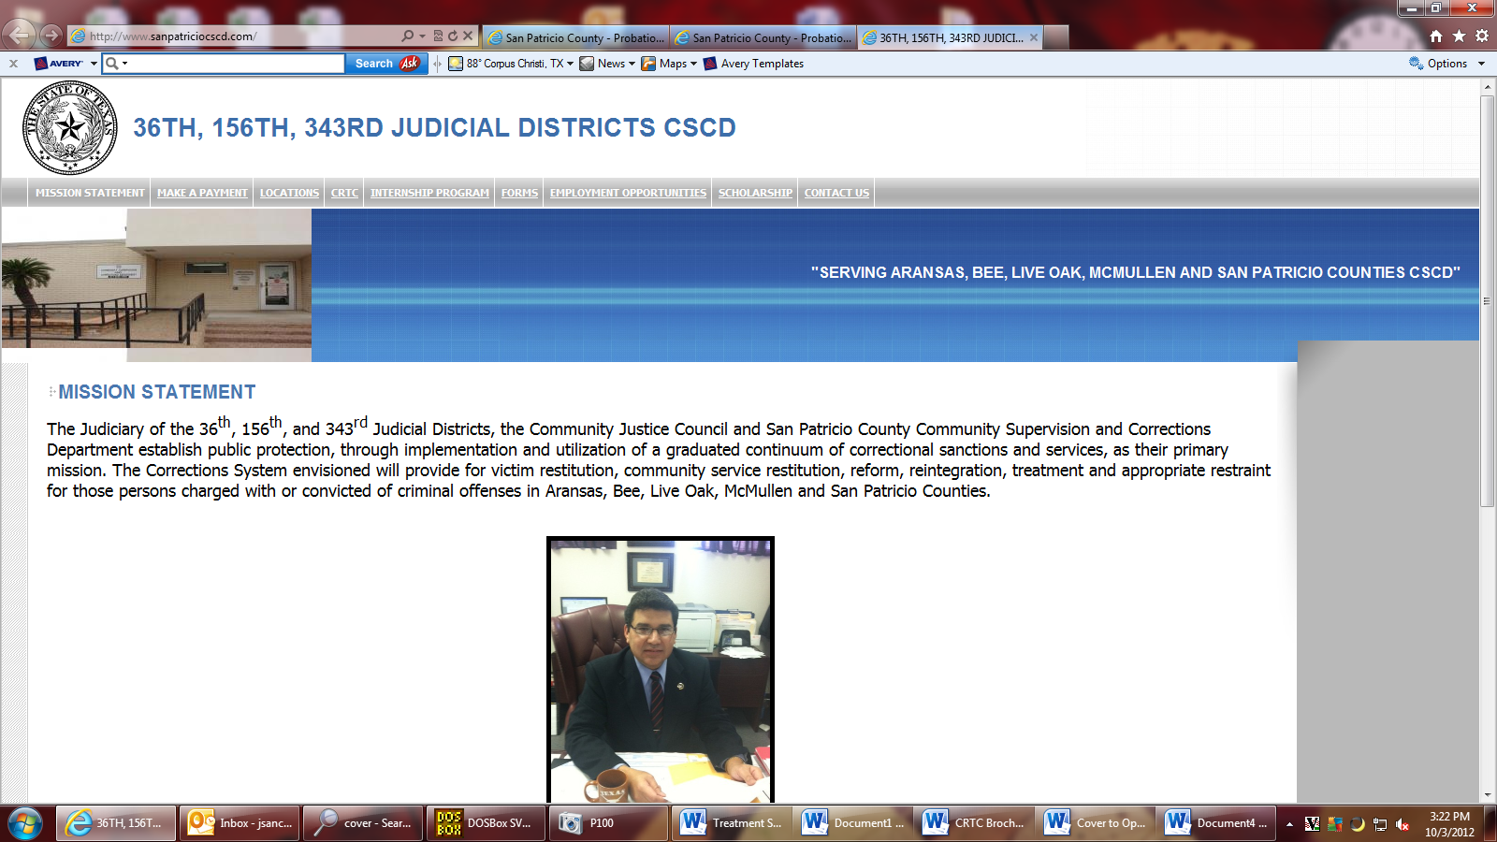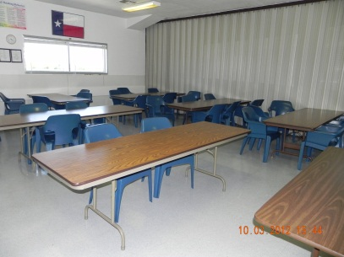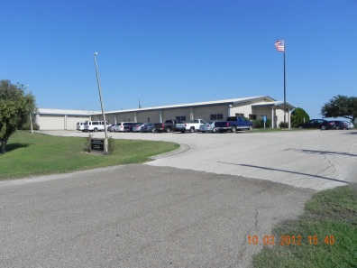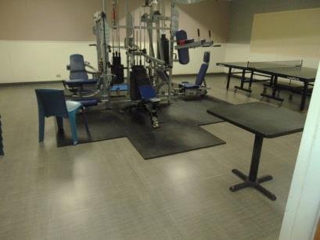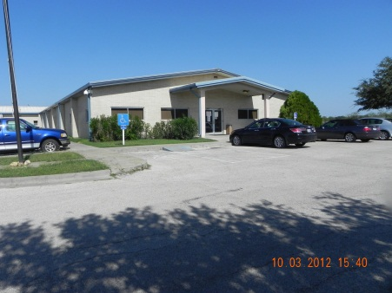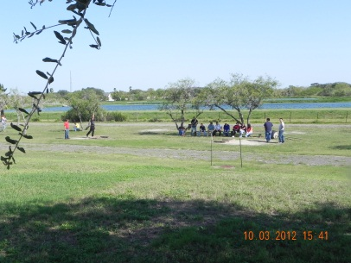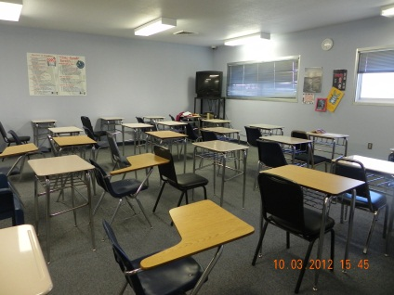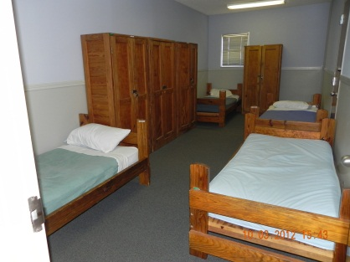

Coastal Bend Regional Intermediate Sanction Facility

800 North Vineyard

Sinton, Texas 78387

(361) 364-4323



**Jorge Felix Sanchez**

**Director of CBRISF**

**Continuing Care** occurs concurrently in the Reintegration/Employment Phase. Aftercare classes are held weekly at the center upon residents return from work.

**90 Day Substance Abuse/Employment Track** available to misdemeanor defendants who meet the basic admission criteria.

Residents are rewarded for good behavior.

Residents can incur consequences for bad behavior which may extend or delay their program time. **Minimum program is 6 months and Maximum program is 9 months.** Upon completion of the program Residents are transferred to an Intensive Supervision Program (ISP) caseload.

Bed capacity 70: 58 Males 12 Females **Currently no waiting period**

**Eligibility to CBRISF Program:**

-Defendant must be 18 years of age

-Current offense and/or criminal history must reflect drug/alcohol abuse and/or addiction

-Felony or Misdemeanor level offenses

- No 3G offenders

- No Title 5 offenders

- No Sex Offenders

- No Offenses involving intentional bodily injury, death or the use of a deadly weapon are not eligible to the program if instant case.

|  |
| --- |
|  |

|  |
| --- |
|  |

**The Coastal Bend Regional ISF** offers a 6 to 9 month in-patient residential substance abuse treatment and Cognitive Track with reintegration/employment services utilizing evidence based cognitive and behavioral models by Kenneth Wangberg and Harvey Milkman (*Criminal Conduct and Substance Abuse Treatment)* focusing in strategies for self-improvement and change. Residents are introduced to the Alcoholics Anonymous and 12 Step Program philosophies, Narcotics Anonymous, and Moral Reconation Therapy designed for self-discovery and modifying deviant thinking and negative behavior fundamental to reducing recidivism.

**Treatment Phase** is 3 months. Residents attend substance abuse educational classes, engage in group processes, personal testimonials are shared; role-play situational scenarios to restructure atypical thinking and behavior. Homework is assigned and processed. Recreational activities and general housekeeping is enforced. Residents transition to the Reintegration/ Employment Phase.

**Reintegration/Employment Phase** is 3 to 6 months. Residents work on resume writing, learn job interviewing skills, job search, and work through 5 levels. Each level earns privileges such as: telephone calls, TV privileges, visitation privileges, and can earn 24 to 48 hour furloughs with good behavior and with no infractions.

IT SUPPORT SOLUTIONS

• Enim iriure accumsan epulae.

• Molior vicis feugiat.

• Quadrum quidem nisl ea.

• Haero ut nutus accumsan.

• Genitus, te vero, erat.

***Research shows that Substance Abuse Programs with an employment component have better results than programs without an employment component.***



Coastal Bend Regional Intermediate Sanction Facility

“Freedom through responsibility”

.